|  |  |  |  |  |  |
| --- | --- | --- | --- | --- | --- |
| **Stakeholder** | **Unaware** | **Resistant** | **Neutral** | **Supportive** | **Leading** |
| customer | C D |  |  |  |  |
| stores | C |  | D |  |  |
| restaurants | C |  | D |  |  |
| clinics | C |  | D |  |  |
| medical centers | C |  | D |  |  |
| google map | C D |  |  |  |  |
| sponsor |  |  | C | D |  |
| team |  |  |  |  | C D |

**C:** Current **D:** desired

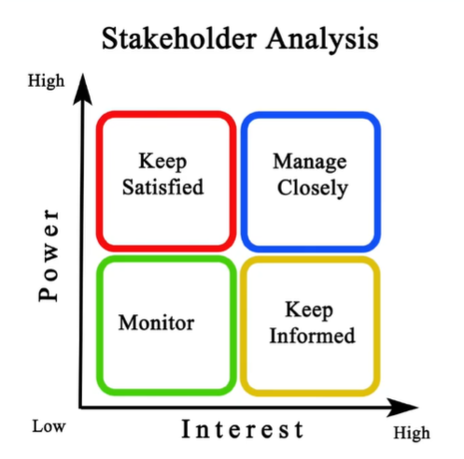

Sponsor

Team

stores

restaurants

clinics

medical centers

google map

Customer / User

|  |  |  |  |  |  |
| --- | --- | --- | --- | --- | --- |
| **Message / purpose** | **Responsibility** | **Audience** | **Medium** | **Contents** | **Frequency/ timing** |
| Project status | PM | stores  restaurants  clinics  medical centers | Meeting |  | Per 2 weeks |
| Team status | PM | Sponsor | Meeting |  | Per week |
| Project review | PM | Sponsor | Meeting |  | Per week |